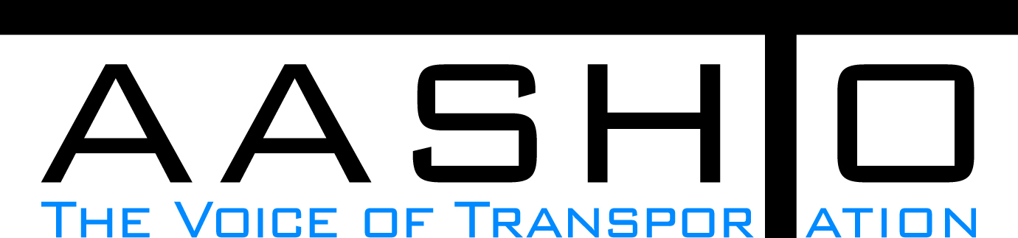Domestic Scan Proposal Form
AASHTO is soliciting topic proposals for a Calendar Year 2013 US Domestic Scan Program (NCHRP Panel 20-68A). Each selected scan topic will be investigated through site visits to three to six locations for approximately a two week period or less (type 1), by webinar (type 2) or peer exchange (type 3) conducted by a group of eight to 12 transportation professionals with expertise in the selected topic area. Proposed topics should meet the following criteria:
- Address an important and timely need for information by transportation agencies;
- Are of interest to a broad national spectrum of people and agencies;
- Are complex and also “hands-on,” meaning they lend themselves particularly well to exploration through on-site visits; and
- Are sufficiently focused that the tour participants are able to investigate and understand key issues in the limited time available on the tour.
This form is designed to collect the full length of your proposal. Sections requiring essays have unlimited space for you to use. Contact information has some limited text. Use your TAB key to advance to the area where you need to complete information.
Proposals should be returned no later than OCTOBER 15, 2012.
Proposal Contact Information
Name | Bryan Cawley | Address | Federal Highway Administration  Room E75-334  1200 New Jersey Avenue, SE  Washington DC, 20590
Title | Construction Management Team Leader | E-mail | bryan.cawley@dot.got
Member Department | Federal Highway Administration | Telephone number | 202-366-1333
AASHTO Committee |  | Date of submission | 10/15/2012

Title of Proposed Scan

Civil Integrated Management (CIM)

Problem Statement (What topic is to be examined? What drives the need for the scan? Why now?)
With limited resources and public expectations higher than ever, all parties to highway construction projects must work together and utilize emerging intelligent construction technologies and partnering for the fast, efficient, and safe delivery of projects. FHWA and the three national associations—AASHTO, ARTBA, and AGC—are jointly promoting “Civil Integrated Management” (CIM) to highlight these types of resources.

The purpose of this scan is to examine projects that utilize CIM technologies and partnering efforts between State DOTs, consultants, contractors, and materials suppliers. Over the past 20 years we have seen a dynamic evolution in the use of computers to assist in highway construction efforts. Whether it is the computer driven total station, laser guidance systems, automatic machine guidance systems, 3D, 4D, or 5D modeling of complex construction strategies, or remote modeling of assemble of bridge elements, we have the potential to be working more efficiently and accurately than ever before. In addition, with the evolution of contract administration from the design-bid-build of telling the contractor how and what to build, we are now using contract administration tools that have the potential to enhance partnering between owners, consultants, materials suppliers, and contractors to optimize just in time delivery of services and materials. However, with these advancements in technology and relationships there still is a lack of understanding the art associated with brining the right team, technology, and project together for optimum efficiency and productivity.

Scan Scope (What specific subject areas are to be examined? Which cities and states might be visited? Which agencies/organizations (including specific departments or types of staff if applicable)?
This scan will consider organization factors (e.g. size of program degree of centralization or decentralization, and outsourcing) that may influence a state DOT, consultant, materials supplier, or contractors’ ability to utilize CIM. Many states, some consultants, contractors, and materials suppliers have used individual technologies and forms of partnering, but a limited few have taken CIM to the level of utilizing project management systems in a data cloud environment, with alternative contracting, innovation in survey, information modeling for construction, innovations in subsurface utility work, and utilizing real time verification. This project will identify a sample of these CIM type projects from across the nation for the scan. During the scan, interviews will occur with project management, design, materials suppliers, and construction staff to assess the effectiveness of the technology and partnering efforts is in achieving the state DOT’s, consultants, materials supplier, and contractor performance measures and goals.

Anticipated Scan Results (What key information is to be gained? What information is to be shared after the scan? Who would the audience be for this information?)
The results of this scan will be the identification of when and where to effectively employ intelligent construction technology in an effective manner to achieve desired performance goals. In addition, the results will identify effective means of partnering between state DOT’s, consultants, contractors, and materials suppliers in utilizing intelligent construction technology to work toward common performance goals.

The final report of the scan will contain an overall synopsis of scan visits and individual project visits with conclusions focusing upon:
• Identified proven intelligent construction technologies that should be further deployed,
• Common construction project performance measures for state DOTs, consultants, materials suppliers, and contractors, and
• Successful techniques of partnering in this new age of virtual meetings, wireless data sharing, and paperless communication.

Benefits Expected (Including potential impacts on current technology or procedures)
The benefits of this scan will be the accelerated deployment of highway construction projects utilizing emerging intelligent construction technologies and partnering for the fast, efficient, and safe delivery of projects. This will directly equate to cost and time saving with improved productivity for design and construction activities of highway projects.

